Project Report Template

**1.INTRODUCTION**

The world’s population is more than three times larger than it was in the mid-twentieth century.

The global human population reached 8.0 billion in mid-November 2022 from an estimated 2.5

billion people in 1950, adding 1 billion people since 2010 and 2 billion since 1998. The world’s

population is expected to increase by nearly 2 billion persons in the next 30 years, from the

current 8 billion to 9.7 billion in 2050 and could peak at nearly 10.4 billion in the mid-2080s.

purpose

• Define Problem / Problem Understanding

o Specify the business problem

o Business requirements

o Literature Survey

o Social or Business Impact.

• Data Collection & Extraction from Database

o Collect the dataset,

o Storing Data in DB

o Perform SQL Operations

o Connect DB with Tableau

• Data Preparation

• Prepare the Data for Visualization

• Data Visualizations

o No of Unique Visualizations

• Dashboard

o Responsive and Design of Dashboard

• Story

o No of Scenes of Story

• Performance Testing

o Amount of Data Rendered to DB ‘

o Utilization of Data Filters

o No of Calculation Fields

o No of Visualizations/ Graphs

• Web Integration

o Dashboard and Story embed with UI With Flask

• Project Demonstration & Documentation

o Record explanation Video for project end to end solution

o Project Documentation-Step by step project development procedure

EMPATHY MAPProject Report Template

1.INTRODUCTION

The world’s population is more than three times larger than it was in the mid-twentieth century.

The global human population reached 8.0 billion in mid-November 2022 from an estimated 2.5

billion people in 1950, adding 1 billion people since 2010 and 2 billion since 1998. The world’s

population is expected to increase by nearly 2 billion persons in the next 30 years, from the

current 8 billion to 9.7 billion in 2050 and could peak at nearly 10.4 billion in the mid-2080s.

purpose

• Define Problem / Problem Understanding

o Specify the business problem

o Business requirements

o Literature Survey

o Social or Business Impact.

• Data Collection & Extraction from Database

o Collect the dataset,

o Storing Data in DB

o Perform SQL Operations

o Connect DB with Tableau

• Data Preparation

• Prepare the Data for Visualization

• Data Visualizations

o No of Unique Visualizations

• Dashboard

o Responsive and Design of Dashboard

• Story

o No of Scenes of Story

• Performance Testing

o Amount of Data Rendered to DB ‘

o Utilization of Data Filters

o No of Calculation Fields

o No of Visualizations/ Graphs

• Web Integration

o Dashboard and Story embed with UI With Flask

• Project Demonstration & Documentation

o Record explanation Video for project end to end solution

o Project Documentation-Step by step project development procedure

EMPATHY MAP :

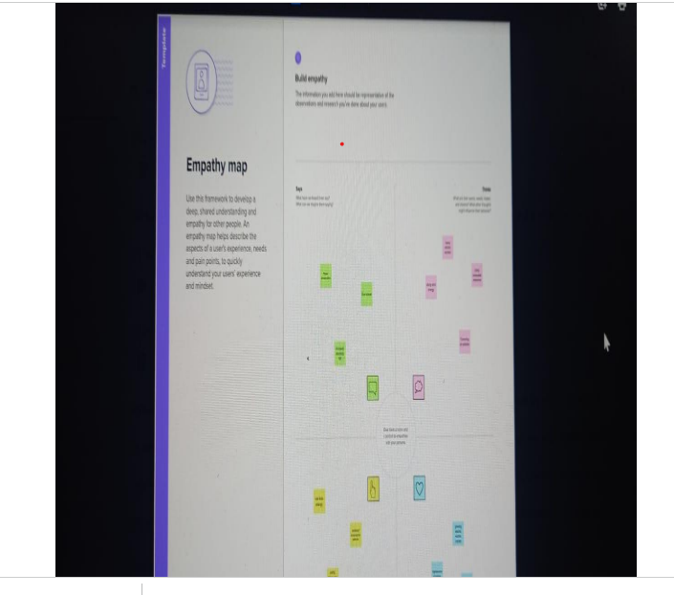

B rainstorming map:

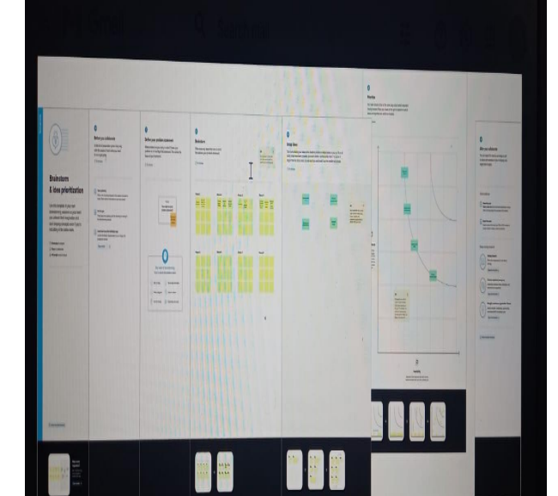

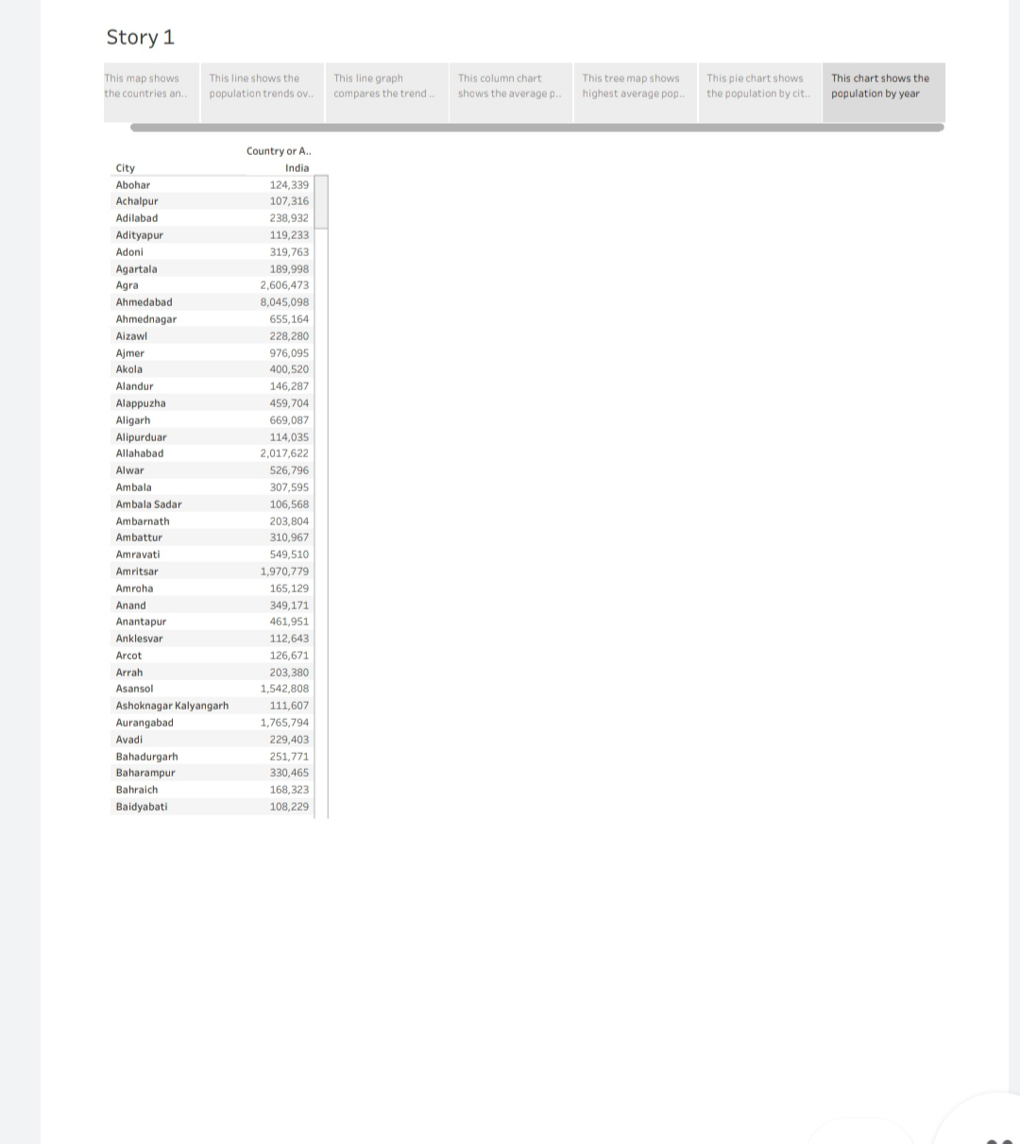

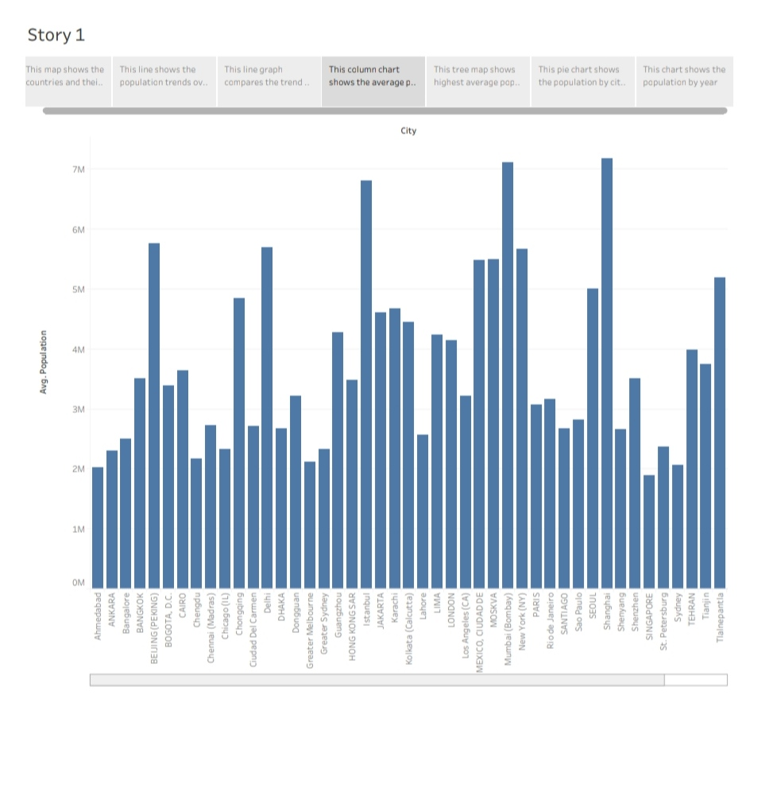

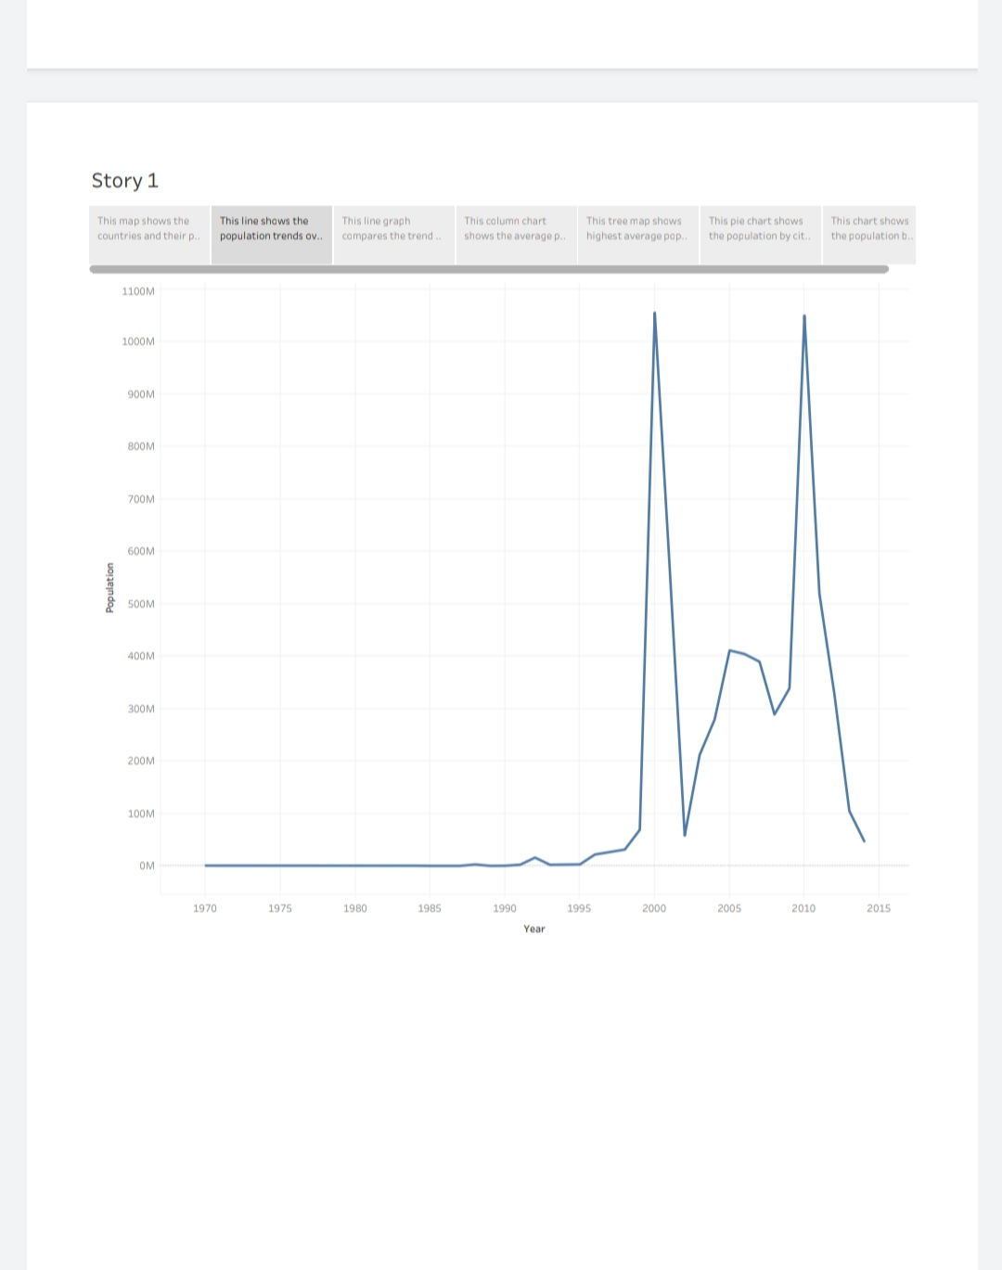

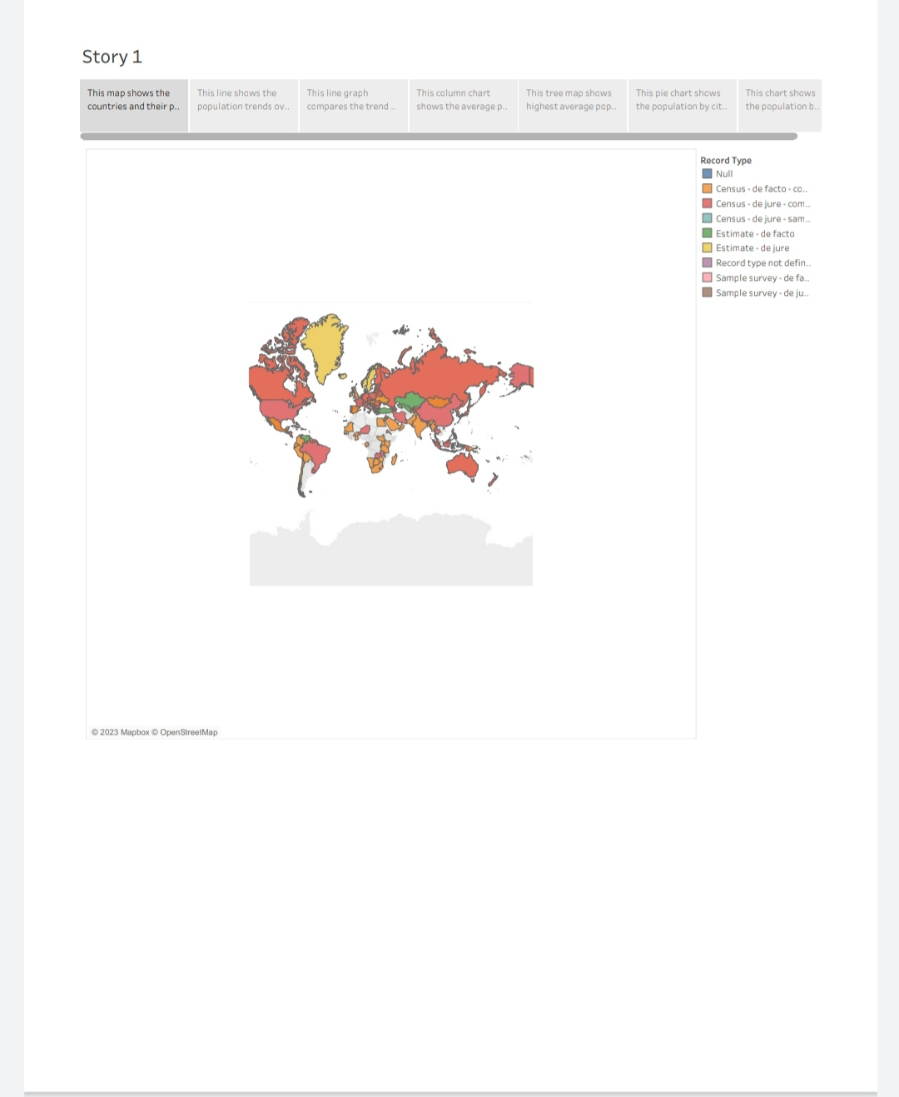

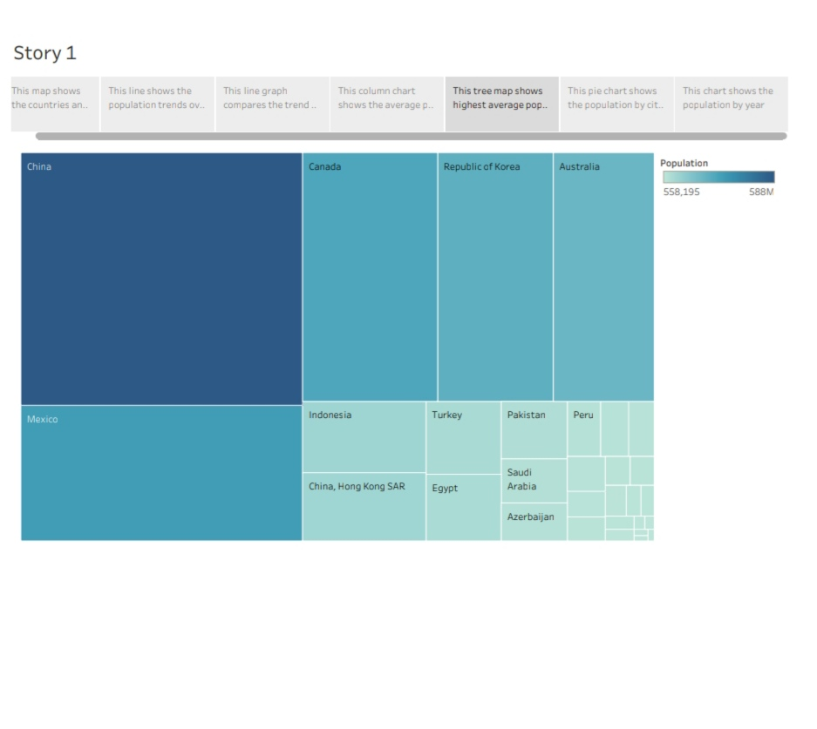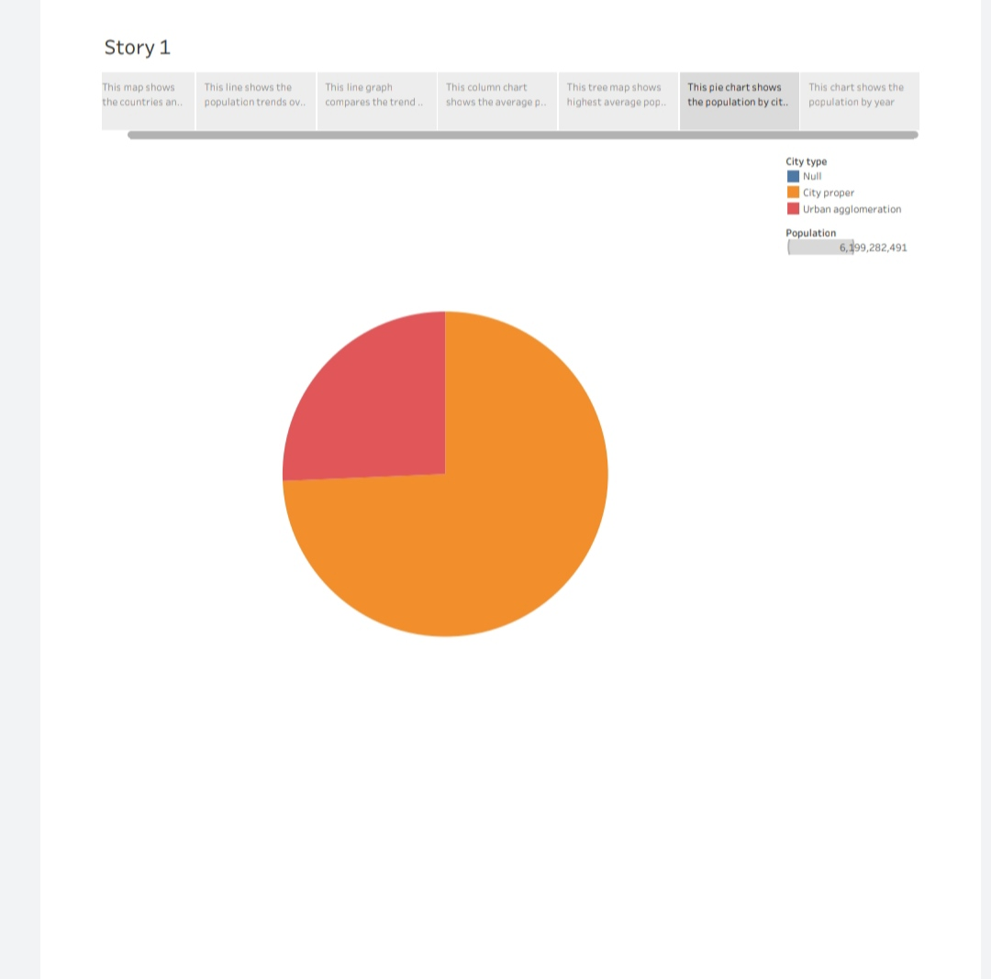

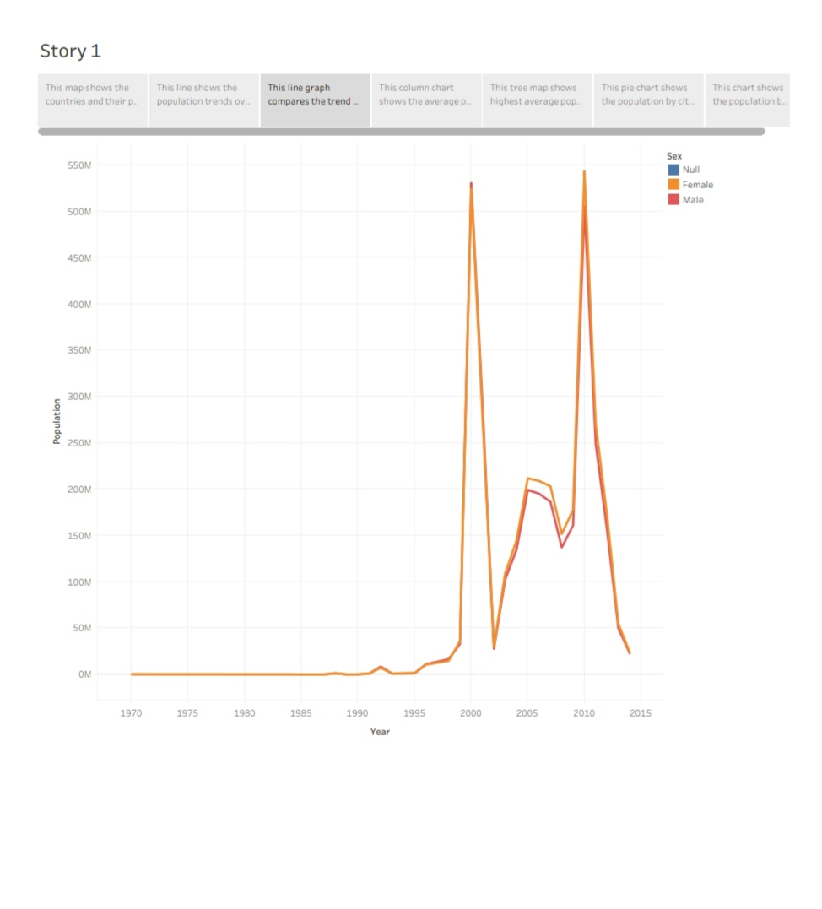ADVANTAGE AND DISAVANTAGE;

Advantages Disadvantages High Performance Poor Versioning Mobile-Friendly No automatic refreshing of reports Extensive customer resources Need manual effort Excellent mobile support Not a comprehensive solution Easy to upgrade No version control Low cost Requires SQL knowledge Quality Customer Service - Ease of Use - Application; The objective of this scheme is to identify potential training providers, to impart various skill trainings based on current industry gaps. Through this flagship program the students will be able to get trained and ensure they get jobs according to their skill sets. We will also offer career and academic guidance to students in state educational institutions. conclusion On completion of the course, the students will be able to Understand the leading technologies and apply them for solving real-world problems

● Understand the concepts of design thinking and agile methodologies

● Develop professional skills like teamwork, time management, communication and project management skills

● Understand various digital tools & best practices followed in the industry

● Develop the products from scratch i.e. idea to working prototype

● Industry course completion certificate from IBM. future scope We take our “We grow talent, talent grows us” culture belief to heart by focusing on developing ADVANTAGE AND DISAVANTAGE;

Team leader: <https://trailblazer.me/id/abithag12>

Team member: <https://trailblazer.me/id/abijj6>

Team member: <https://trailblazer.me/id/abisc33>

Team member: <https://trailblazer.me/id/abishasv>

Conclusion:

On completion of the course, the students will be able to ● Understand the leading technologies and apply them for solving real-world problems ● Understand the concepts of design thinking and agile methodologies ● Develop professional skills like teamwork, time management, communication and project management skills ● Understand various digital tools & best practices followed in the industry ● Develop the products from scratch i.e. idea to working prototype ● Industry course completion certificate from IBM.

future scope:

We take our “We grow talent, talent grows us” culture belief to heart by focusing on developing our Moment Makers. An ever-growing Radisson Academy offer aims to equip you with key skills and boost your potential through customized training programs right from your day one. We are dedicated to individual development and have a strong performance culture that facilitates your career growth at all levels